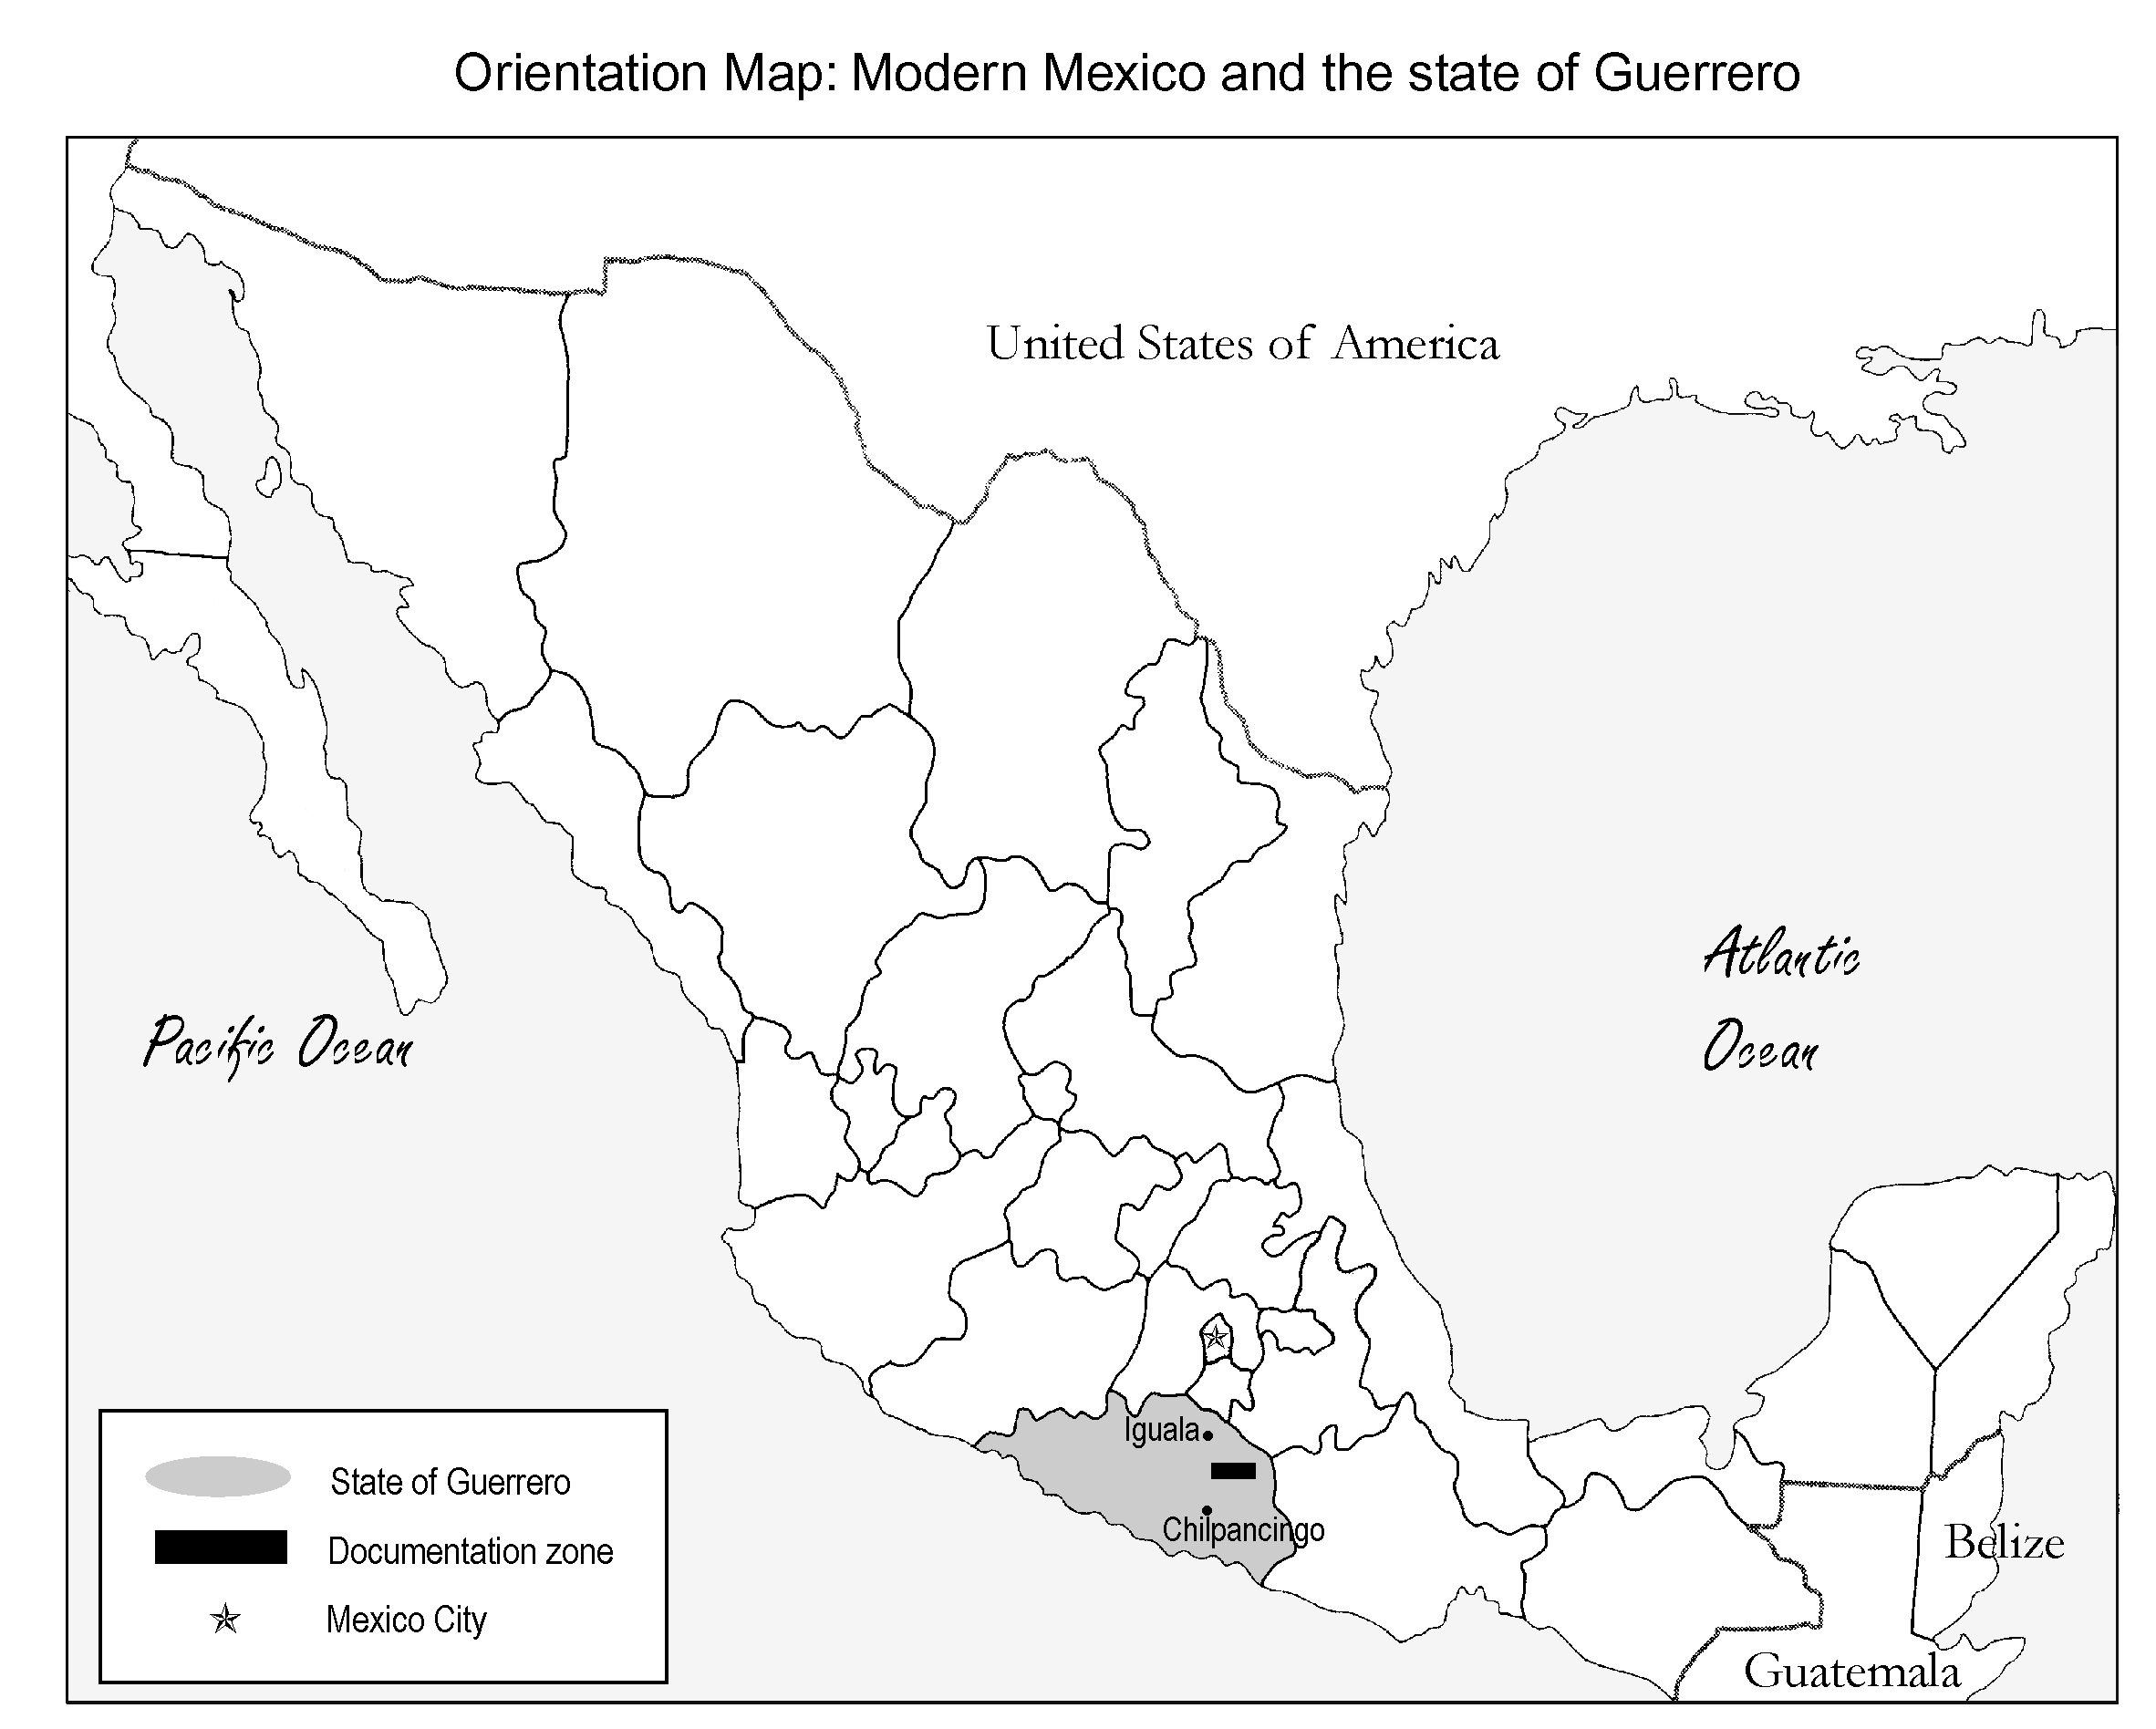

table of contents

1. Abstract | 1
Detailed project description……………………………………………………………………  2. Area of study……………………………………………………………………………..  3. Endangerment: An overview of the problem of urgency………………………………...  3.1 Balsas Nahuatl as a linguistic community  3.2 Symptoms of language death  3.3 Balsas Nahuatl as an endangered language  3.4 Politics and priorities of language documentation  4. Language documentation of Balsas Nahuatl: Past and future……………………………  4.1 State of descriptive work  4.2 Language documentation synergy  4.3 Future of the Balsas Nahuatl Literacy and Language Documentation Project  5. Conclusion………………………………………………………………………………. | 3  5  17  27
6. Working program and time schedule | 28
7. Applicant’s previous work on the subject | 30
8. Letters of community and institutional support……..………………………………………  - Juan Domínguez Calixto, director of the bilingual school district of the Balsas River Valley  - Comisario municipal propietario and suplente of the village of Ameyaltepec  - Comisario municipal propietario and bilingual school director of the village of Oapan  - Sylvia Schmelkes, director of bilingual education, Secretaría de Educación Pública  - visa and official position as advisor to Sylvia Schmelkes, director of bilingual education  - bilingual schoolteachers of Oapan  - Comisario municipal propietario, proof of Amith residence in San Agustín Oapan  - Florencia Marcelino and Inocencio Jiménez, example of informed consent agreement  - Director of the Dirección de Organización y Capacitación Social of the Instituto Nacional Indigenista | 34
9. Similar applications to other funding institutions | 46
10. Name of proposed recipient of grant | 46
11. Bibliography of project description | 46
12. Web documentation | 49
13. Flowchart of Nahuatl Learning Environment | 50
14. Budget: Calculation and substantiation of costs | 51
15. CVs of major participants………………………………………………………………….  - Jonathan D. Amith  - Bernard Comrie  - Barbara Stiebels  - Ortolf Karla  - Fernando Nava  - Susan Guion  - Nelly Diego  - Adolfo Navarro | 62

