Table of contents:

1 | Overview of JLex | -
2 | Designing a lexicon in Shoebox (or other database program)
3 | Nahuatl Setup Module and My Dictionary
3.a | Upload lexicon to JLex | 2
3.b | Create User Database
3.c | Create My Dictionary Database
3.d | The Nahuatl Lexicon Search Page
 | Querying the lexicon through JLex
 | Creating a search form
 | Displaying the results
3.e | Data cleansing  Valid XML documents  Valid links
3.f | Create Account/Login to My Dictionary Account

Note for SH construction:
Advantages of creating a hierarchy: Attempt to create groups in Shoebox. The smaller the group the more manageable the MySQL tables.
3.
Nahuatl Setup Module and My Dictionary

The Nahuatl Setup Module will always be with the stylesheets and html files. At present it is located in http://www.balsas-nahuatl.com/beta/lex/nahuatl_setup.html The purpose of nahuatl_setup.html is to give full access to the functionality of all tools associated with JLex (e.g., datacleansing and My Dictionary). The functionalities presently available are:

- Upload lexicon to JLex: This link will take you to the database upload module.
- Create User Database : This link will erase the previous version of the User database and create a new one with no users (it empties the database). Also, a user database MUST exist before My Dictionary can function properly! NOTE: For this to work properly, you must have a folder labeled "user" containing the relevant schema file. This should be provided with the installation.
- Create MyDictionary Database : This link will erase the previous version of My Dictionary, replaceing it with a new version with no users (it empties the database). Be sure to first run the Create User Database using this link.For this to work properly, you must have a folder labeled "mydict" containing the relevant schema file. This should be provided with the installation.
- The Nahuatl Lexicon Search Page
- Data Cleansing
- Create Account/Login into My Dictionary account

Each of these will be described in the following sections.

3.a
Database upload module

- Name of the project in lowercase (suggested name would be the language name or lexicographer name):
  - One function of “project name” is to create a namespace. Every group in the XML database becomes a separate table in MySQL. For example, the se group becomes one table, the sea group becomes another table, etc. The name of the project is used to distinguish group/tables of one XML lexicon from another. The namespace is intended to avoid conflicts between different people's lexicon/database when there is more than one lexicon on a given server.
  - A second function of the “project name” is to provide a name for the folder created for each lexicographer (and to which they may eventually be given access). This folder is at the same level as the folder containing the php code (e.g. php4, php5, for version).

- Form of the database
  - Option: “Structured XML (no modifications necessary)”: This option is for those lexicographers who do not want to change the hierarchy of their XML database. For this option Hyperfex infers the schema from the uploaded XML and the user does not need to provide any schema file that will change the structure.
  - Option: XML requiring structure: This option is for those who wish to use a schema to change the structure of the XML file (i.e., creating new groups not in the original XML file).
  - Option: Shoebox: pending development
  - Option: Tab/Comma delimited file: pending development
- Schema: This file has to be uploaded by the administrator within the php folder. The administrator of the lexicon is the only one allowed at this point to upload to the php folder. See Help File associated with this function (pending development)
- Head tag:
  - In an XML file: This is the name of the top level tag that surrounds each entry within the XML/lexicon. If you are not sure what this is, look at the XML file for the element/tag that surrounds each single entry
  - Tab/comma delimited: (pending development)
- ID field: When the lexicographer provides a schema to restructure the XML file, Hyperlex checks to ensure that each record follows the provided schema. In the event that an error is discovered, Hyperlex reports the value (content) of the ID. For example, in the Nahuatl database each record has a field called <ref/> that has a unique numerical value. Hyperlex will report the ref (i.e. number) of any entry that does not match the schema. All errors that are found must first be corrected and then XML lexicon re-uploaded to the server.
- Database file name on server: This is the name of the lexical database (e.g. olddictionar.xml) that has been uploaded to the server in the php folder.
- New Database Name: This will be the name of the XML file (e.g. newdictionary.xml) following any modifications made during the upload process. These include:
  - Restructuring
  - Field deletion (see below)
  - Creation of fields stripped of characters defined during the upload (see below)
- Sort fields: The sort fields box will contain an ordered list of fields separated by spaces (e.g., field1 field2 field3). The fieldnames must be fieldnames in the uploaded database Note that JLex converts every fieldname to lowercase in the “new database” even if originally in uppercase. The sort fields function is used to create a new column, called “alpha,” in the database. The algorithm is as follows. The value of alpha is determined as follows:
  - Check to see if field #1 (e.g., lxa) has a non-empty value. If so, this becomes the value of “alpha.”
  - If field #1 is empty, check value of field #2. If this is a non-empty value, this becomes the value of “alpha.”
  - If all sort fields are empty the value of alpha will be empty and the record will sort first
  - The value put into alpha is stripped according to the equivalences established in the following box.
- Symbols to be replaced: This function creates “stripped columns” for searching the modified database. These database columns are named field1_s, field2_s, etc. This function is useful to facilitate searches for words containing accents, other diacritics, or any characters that are difficult to type. For example, if a field1 contains babà the field1_s will contain baba if the symbols to replaced box contains à = a. This will only work if the field is uploaded and checked (see below) as to be stripped. For example
á = a
é = e
í = i
ó = o
ú = u
Á = A
É = E
Í = I
Ó = O
Ú = U
Ñ = N
ñ = n
ü = u

- First symbols to be replaced: This function is a modification of ‘Symbols to be replaced’. It allows the lexicographer to define replacement rules which will only be applied to the first character of a field. For example, if field1 contains “^hel^lo”, and the rule ^ = ‘’ is provided, the stripped result will be “hel^lo”.
- Selection of fields to be uploaded and stripped
This page contains three columns:
- fieldnames: all fieldnames in the original lexical database
- checkbox: when selected JLex does not include this field in the modified lexicon
- checkbox: a checkbox is present in this column when the content of the field in the first column contains one of the characters that the user has elected to replace. For example, if in the Symbols to be replaced box the lexicographer has entered
á = a
é = e
í = i
JLex will provide a checkbox in column 3 for all fields that contain /á/, /é/,
/í/.
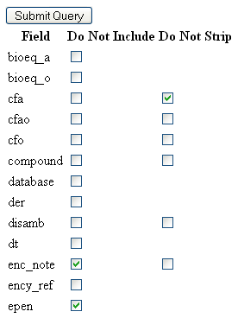

In the above case, the lexicographer has chosen not to upload the fields enc_note and epen. The fields cfa, cfao, cfo, etc. have characters that may be stripped and the lexicographer has chosen not to create a stripped field for cfa.
- NOTE: This list contains two categories of fields. The first category contains all those fields existing in your lexicon which contain data. The second category contains those fields which serve only structural purposes in the xml file. For example, consider:
<group>
<field1>hello world</field1>
</group>
In this example, “field1” will be listed under the first category of fields, where as “group” will be listed under the second category.
- An asterix next to the checkbox indicates the field existed in the previous version of the database.
3.b
Create User Database

There are two types of “user databases:
- a register of all users
- the references for each user’s My Dictionary

The user database consists of six columns:
- first name
- last name
- username
- password
- email
- date stamp (for date of account creation)

Database creation: for the lexicographer/administrator
  - click on Create User Database.
  - Set up the first user by filling in the box: “If you have not already created an account, please fill at the form below:”
  - Note: outside users will register and set up an account through the Search Form Interface by clicking on “Login to My Dictionary”
  - Cookies must be enabled for outside users to access their account in “My Dictionary”

Note: Creating User Database should only be used when initially setting up a database or if the administrator/lexicographer wants to delete all user accounts. Be careful when using this functionality.
3.c
Create MyDictionary Database

To make My Dictionary functional the lexicographer/administrator must click on this link. This sets up the My Dictionary database. The lexicographer/administrator may then check if the database is working by logging in and storing entries.

Note: for the two databases to work there must be folders with the following content:
mydict containing the file schema.xml
User containing the file schema.xml

For the user and My Dictionary account databases to work these files must be present in their respective directories and the directories must be at the same level as the php folder.
3.c
Creating a Search Form

A. Creating a search template in XML
JLex provides a search interface that looks like this:

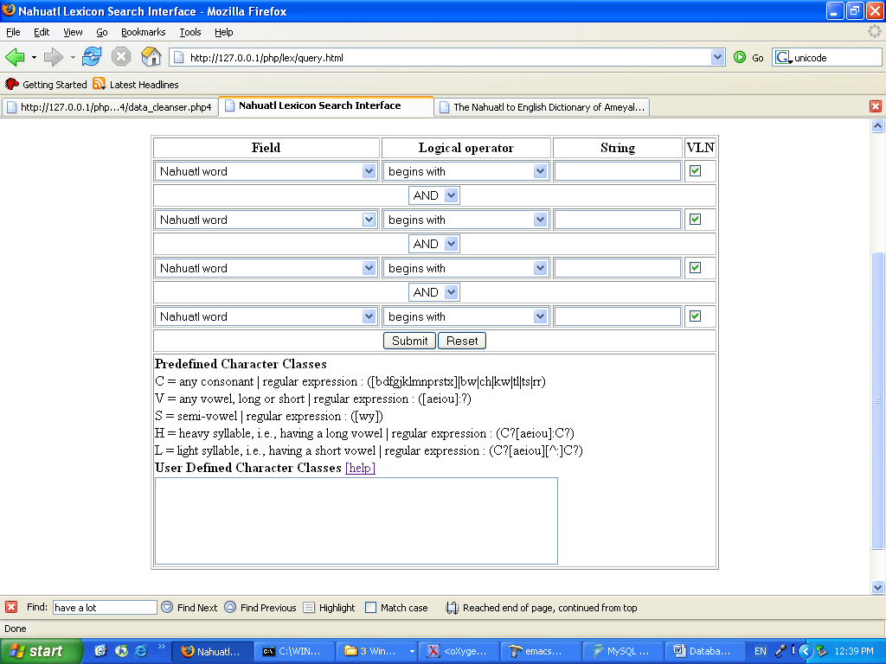 | 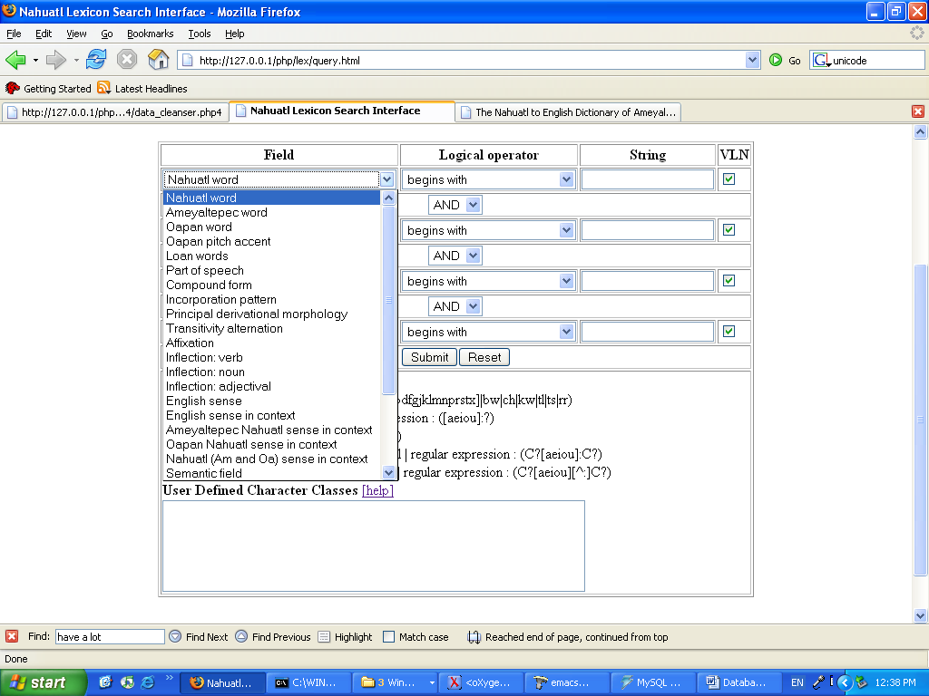

The JLex settings for querying the lexicon are contained in a file, placed in the user’s project directory, called query.xml. The following is the present file:

<?xml version="1.0" encoding="iso-8859-1"?>
<?xml-stylesheet href="../lex/search_form.xsl" type="text/xsl"?>
<QUERY>
<DATABASE>nahuatl</DATABASE>
<SORT_ORDER>alpha</SORT_ORDER>
<NUM_CONDITIONS>4</NUM_CONDITIONS>
<PHRASES_AND_FIELDS>phrases_and_fields.xml</PHRASES_AND_FIELDS>
<REG_EXPS>reg_exps.xml</REG_EXPS>
<STRING></STRING>
<CONNECTIVES>connectives.xml</CONNECTIVES>
<NEUTRALIZE></NEUTRALIZE>
<PREPROCESSING_SCRIPT>neutralize.php4</PREPROCESSING_SCRIPT>
<CHAR_CLASSES>char_classes.xml</CHAR_CLASSES>
<SEARCH_STRIPPED_FIELDS>true</SEARCH_STRIPPED_FIELDS>
</QUERY>

The search form can be customized by changing the values of the tags in this files (e.g., <PHRASES_AND_FIELDS>. The following pages will describe how this is down.

- <DATABASE>nahuatl</DATABASE>
The value of the <DATABASE> tag is the name of the project. This should never be changed. Changing this field will prevent JLex from recognizing where your database is stored.

- <SORT_ORDER>alpha</SORT_ORDER>
The value of the <SORT_ORDER> tag is the field in the database that is used for alphabetization. In uploading JLex the user is allowed to create an alpha field for alphabetization (see above). If for some reason the user wants to change the sort order while maintaining this alpha field, he or she may change the value of the <SORT_ORDER> tag.

- <NUM_CONDITIONS>4</NUM_CONDITIONS>
The value of the <NUM_CONDITIONS> tag is the number of rows in the search form. Users may want to condense the search form by lowering the value of this tag.

- <PHRASES_AND_FIELDS>phrases_and_fields.xml</PHRASES_AND_FIELDS>
The purpose of the phrases_and_fields.xml file is to associate a human readable phrase with a set of fields that are to be searched. Note the following example from the Nahuatl phrases_and_fields.xml file.

<SET>
<ENGLISH>Nahuatl word</ENGLISH>
<SPANISH>Palabra en náhuatl</SPANISH>
<VALUE>lxam lxam_alt lxap lxoa lxoa_alt lxop</VALUE>
</SET>

This section of a file tells JLex to create a row in the FIELDS drop-down menu of the search form that reads Nahuatl word (or Palabra en náhuatl in a Spanish search form) and searches in the database columns (fields) named lxam, lxam_alt, lxoa, lxoa_alt, lxop.
Users modify the content of the drop-down menu by modifying the phrases_and_fields.xml file in the project directory.

- <REG_EXPS>reg_exps.xml</REG_EXPS>
The purpose of the reg_exps.xml file is to associate a human readable phrase with a set of regular expression searches to the database. JLex provides a reg_exps.xml file that covers most searching functions and should not be changed except by advanced users. Note the following example from the Nahuatl reg_exps.xml file.

<SET>
<ENGLISH>ends with</ENGLISH>
<SPANISH>termina con</SPANISH>
<VALUE>field REGEXP '&amp;$'</VALUE>
</SET>

Note that the variable field in <VALUE> tag is a placeholder for the set of field names to be searched (e.g., for Nahuatl word, the fields searched would be lxam, lxam_alt, lxoa, lxoa_alt, lxop); the &amp; string is a placeholder for the value of the string to be searched for (i.e., the value that the user of the interface writes into the String (3rd) column.

- <STRING></STRING>
In the present version of JLex this tag simply creates the String (3rd) column of the Search Form.

- <CONNECTIVES>connectives.xml</CONNECTIVES>
The purpose of the connectives.xml file is to provide a human readable phrase for the logical operators AND and OR in JLex. For example:

<?xml version="1.0" encoding="iso-8859-1"?>
<CONNECTIVES>
<SET>
<ENGLISH>AND</ENGLISH>
<SPANISH>Y</SPANISH>
<VALUE>AND</VALUE>
</SET>

<SET>
<ENGLISH>OR</ENGLISH>
<SPANISH>o</SPANISH>
<VALUE>OR</VALUE>
</SET>
</CONNECTIVES>

establishes the human readable “and” and “y” for the logical operator AND.

- <NEUTRALIZE></NEUTRALIZE>
This is presently used only for the Nahuatl lexicon. It establishes the VLN (Vowel Neutralization or 4th) column on the Search Form.

- <PREPROCESSING_SCRIPT>neutralize.php4</PREPROCESSING_SCRIPT>
This has no function at present. In the future there will be language specific user specific preprocessing function that will allow users to insert their own script into JLex.

- <CHAR_CLASSES>char_classes.xml</CHAR_CLASSES>
The purpose of character classes is to allow users to search on a group of characters (e.g., all vowels, all stops, etc.). The char_classes. xml file creates a symbol to represent character classes. For example:

<SET>
<NAME>CN</NAME>
<ENGLISH>CN = any consonant | regular expression</ENGLISH>
<VALUE>([bdfgjklmnprstx]|bw|ch|kw|tl|ts|rr)</VALUE>
</SET>

The above section establishes the sequence of symbols CN to represent all consonants in Nahuatl. Thus a user who searches for Nahuatl word (1st column/Fields) begins with (2nd column/Logical operator) CNaCN (3rd column/String) will find all Nahuatl words that begin with any consonant, followed by an /a/, and then followed by another consonant.
Note that character classes are often language and orthographic specific. Thus most users will want to modify the char_classes.xml file for their own project.
The Search Form itself also provides a space to define a character class at the time of searching (please see discussion of the Search Form for more information).

- <SEARCH_STRIPPED_FIELDS>true</SEARCH_STRIPPED_FIELDS>
The value true of the <SEARCH_STRIPPED_FIELD> tag tells JLex to always search the stripped versions of fields if they exist. For example, if a user is searching the lexam field and JLex has created a stripped version of this field (lexam_s, without any diacritics; see Database Upload Module #9 and #11), the true value tells the program to search in the lexam_s field every time it searches the lexam field.
If the lexicographer wants to avoid automatic searching of stripped fields the value should be changed to false. The value may also be changed at the time of searching. Please see the section on Search Form below.

B. Transforming the XML Search Template to HTML using OxYGEN
The XML document that is being transformed is query.xml. The XSL template that is being used to transform the Nahuatl Project Search Form is search_form_nahuatl.xsl. Right now this is specific to the Nahuatl project. Other lexicographers will use a generic form of this XSL file called search_form.xsl. This may be edited to create a project specific xsl file (like the nahuatl_search_form.xsl). Note that the advantage of transforming the Search Form to HTML is that user input is cached and thus users who click Back on their browser will return to the form values they had previously chosen.
- Open OxYGEN
- From OxYGEN open up query.xml, which will be in the project folder
- Open Configure Transformation Scenario (wrench button on the toolbar, next to the red arrow/play button; or go to Document > XML Document > Configure Transformation Scencario, or Ctrl-Shift-C)
- Click on New in the Configure Transformation Scenario box
- Give a name that will then appear in the Options Box for the transformation (e.g. Nahuatlsearchform_tran).
- Click the checkbox ‘Use “xml-stylesheet” declaration’ This tells the Configuration to look at query.xml declaration for the stylesheet (e.g., <?xml-stylesheet href="../lex/search_form.xsl" type="text/xsl"?>). The transformation will now be stored under the name given in the preceding step (Nahuatlsearchform_tran)
- Now click the Output tab on the Configure Transformation Scenario box
- Click Prompt for file (or make sure that it is already selected)
- Click OK
- Click Transform Now with the transformation scenario (e.g., nahuatlsearchform_tran) highlighted. Note: to show immediately as HTML click Show as XHTML
- Save result as query.html (or any other name).
- Put it in the Project folder (e.g. Nahuatl). It must be in a path relative to the php folder:
  - ..\[project name]\query.html
NOTE: after performing this transformation once, one can perhaps go immediate to the Apply Transformation Scenario (red arrow on toolbar, Ctl-Shift-T, or Document > XML Document > Apply Transformation Scencario).

Upload lexicon to JLex
This is described in the previous section.

