In some cases, a native term will correspond rather precisely to a scientific taxonomic category, whether it represents a family, tribe, genus, section, or species. For example, the Nahuatl term mēmēya
labels the section Chamaesyce of the genus Euphorbia in the spurge (Euphorbiaceae) family. Because mēmēya basically translates as Chamaesyce, with no caveats or exceptions, the synoptic page on this term will note the coincidence of Indigenous and scientific classifications of the natural environment.
But most often Indigenous and scientific taxonomies do not coincide and thus a simple translation of the Indigenous term is impossible. Instead, the synoptic pages must be descriptive, analyzing and explaining the relationships between the Indigenous and scientific classifications. The following material, on the Nahuatl term chapolin, illustrates a preliminary approximation of the content of one of the more involved synoptic presentations. The online version will be visually richer and organized in various screens (underlined terms below are hyperlinks).
____________________________________________________________________________________________
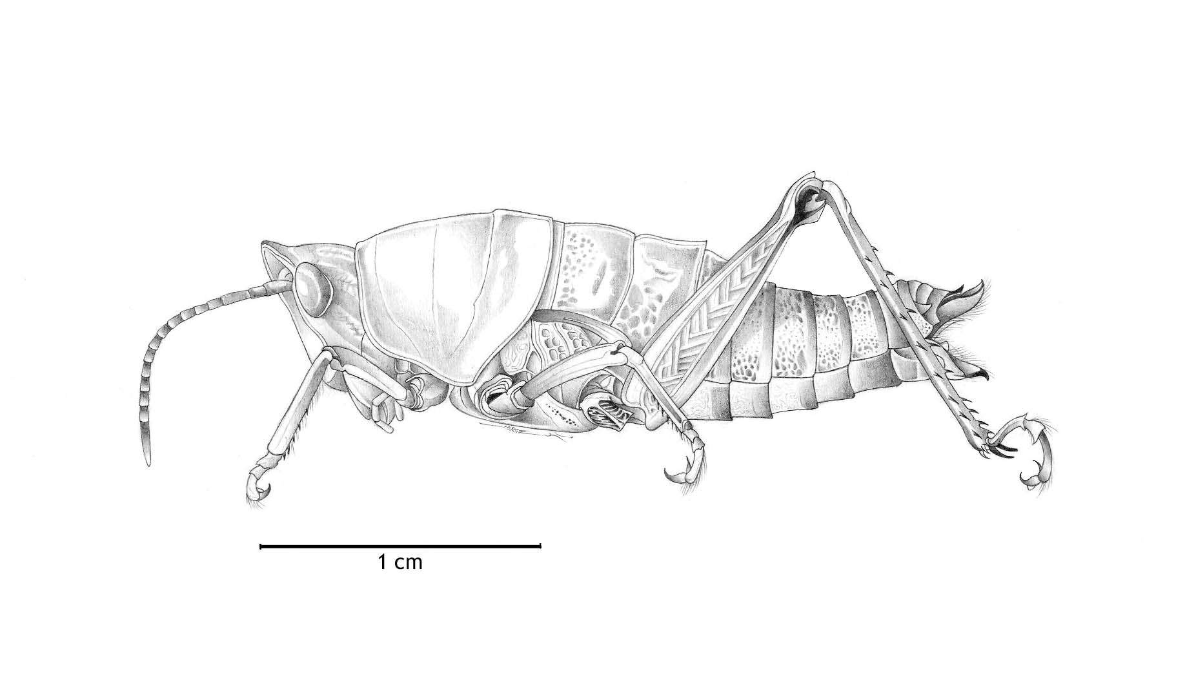
The Náhuatl word chapolin, often translated as ‘grasshopper’, is one of the best-known Nahuatl insect names. It is now a vernacular term (chapulín) in some Latin American countries and is listed as a headword in the dictionary of the Real Academia de la Lengua Española (Spain). All Mexican children are familiar with a Mexico City neighborhood named Chapultepec–the site of a famous mid–nineteenth-century battle against the United States–and many would be able to correctly translate it as ‘grasshopper hill (-tepec)’. In Spanish, ‘chapolín’ usually refers to any of the six Mexican species in the genus Sphenarium, a genus that includes the most widely eaten and commercialized grasshoppers in Mexico, often sold in local markets as a delicacy. But in the Balsas River valley chapolin can acquire up to four meanings depending upon the context of utterance.
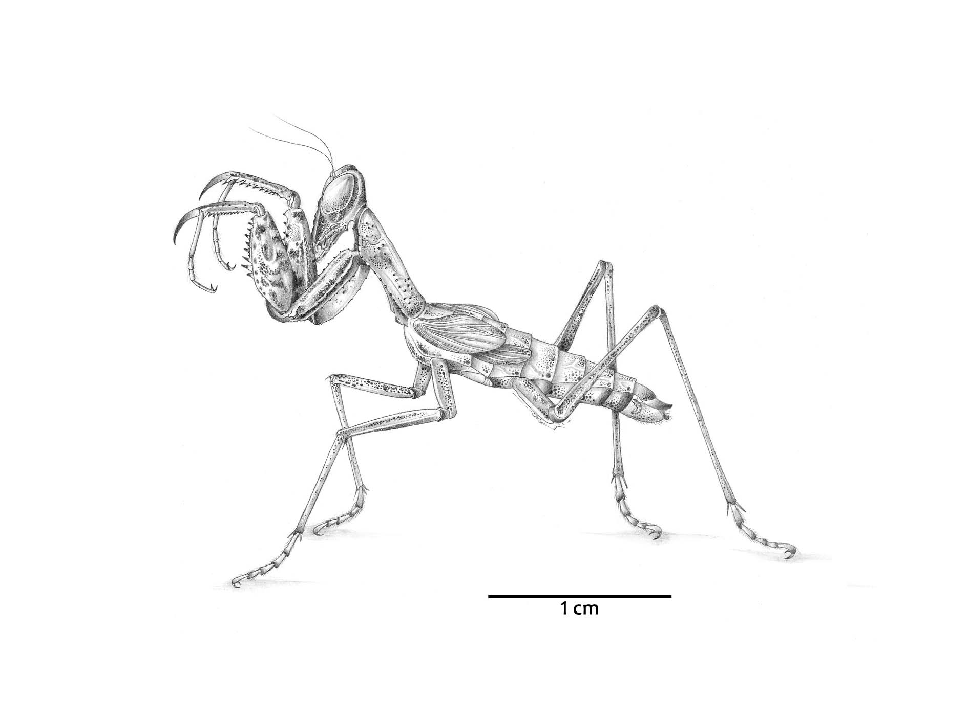
The first meaning of chapolin denotes Sphenarium purpurascens purpurascens (first illustration) the western subspecies of this species, found and consumed extensively throughout Mexico. In the Balsas River valley it is also the most abundant Orthoptera (an order of insects that includes grasshoppers, katydids, and crickets). In a typical day’s hunt it will comprise well over half the species collected. At times speakers will qualify the term by saying kwahli chapolin (literally ‘good’ or ‘real’ chapolín) to distinguish it from other edible insects of the Orthoptera and related orders (Phasmatodea, ‘stick insects’, and Mantidae, ‘mantis’). The Sphenarium purpurascens is also known locally as chapoltekwīkwil, in reference to its spotted or variegated coloring.
The second meaning of chapolin refers to an immediately superior category that includes both the kwahli chapolin and the yēlōchapolin (literally ‘young ear of corn [yēlōtl] chapolín). Speakers designated several collected Orthoptera as yēlōchapolin. These species were all nymphs, with a solid light-green body, caught in late summer when the maize plants were still young. Thus the yēlō- element prefixed to chapolin could refer to the color of these grasshoppers, the fact that they are associated with young maize plants, or the fact that they are nymphs (‘green’, ‘immature’).
In a third sense, chapolin includes all edible insects of the Orthoptera, Phasmatodea, and Mantidae orders. Speakers will commonly say, when referring to an edible stick insect or mantis, “nō chapolin, nō nokwa” (‘it is also a chapolín, it is also edible’). Of the stick insects, tlakōmēmeka (literally, ‘stick-twine’), only one species is edible, and in this species it is only the much larger female that is collected (although an unfortunate male might accidentally make it into the pot). Among the mantis it is also only the female that is eaten. With one, called chachateya, the eggs are consumed as well. There is strong linguistic evidence that chapolin in this third sense references all edible grasshoppers, katydids (also Orthoptera), stick insects, and mantis. A Nahuatl verb cháchapolma is used to mean ‘to hunt chapulines’ and many edible insects in the three above-mentioned orders are considered “catches”.
The fourth sense of chapolin is the most general and one whose defining criteria is morphological: it designates all grasshoppers and katydids, whether or not they are edible. Among the Orthoptera found in the region, the term used in this sense includes the short-horned grasshoppers (suborder Caelifera) and the katydids (family Tettigonidae in the suborder Ensifera) but excludes all types of crickets. Even though in scientific classification katydids are in the suborder Ensifera (along with crickets) and grasshoppers are in the suborder Caelifera, Nahuatl-speakers will join the katydids and grasshoppers in one category.
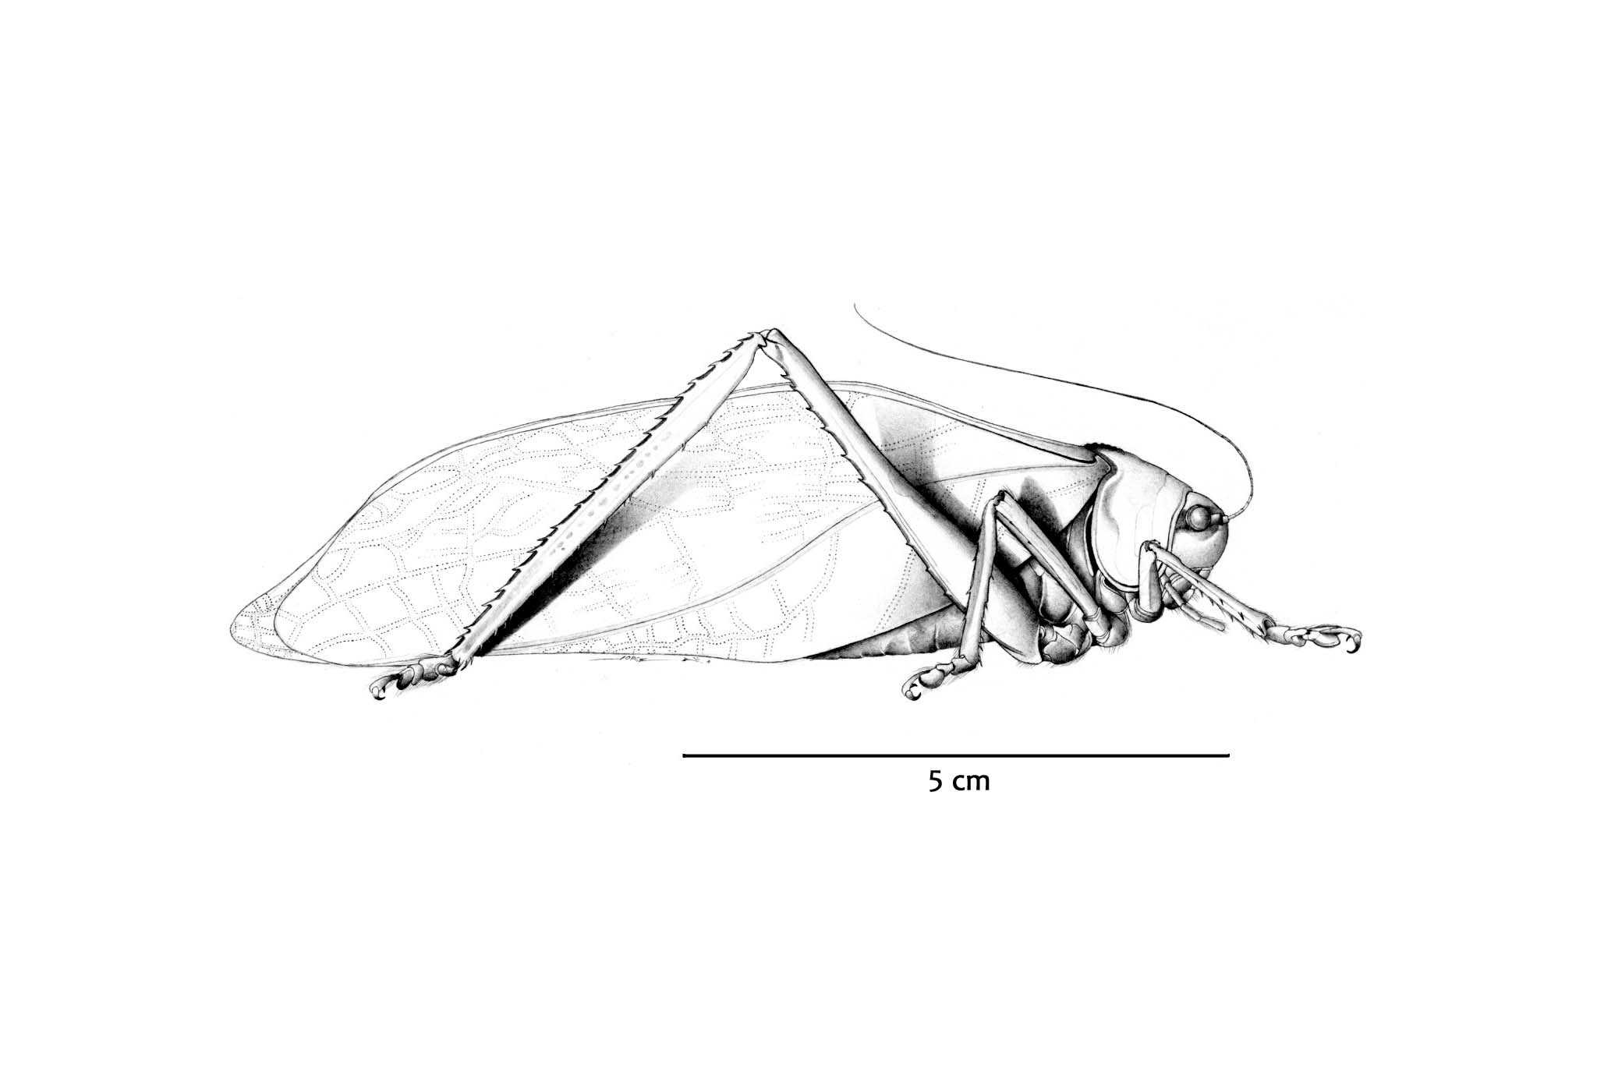
The naming conventions of specific chapolin are quite varied, and a few are mentioned here (see Orthoptera naming). Only two taxa actually contain the term chapolin as part of their name (kwahli chapolin and yēlōchapolin). Some names are onomatopoeic, imitating the sounds the insects make: tēsīs, tepachichi, chowilili. Others are descriptive: kwékwetlaxak (literally, ‘sandal-like’, referring to the form and marking of the pronotum) and tsontekomāma (literally, ‘head carrier’, or ‘no-necked’, see third illustration). Color may motivate the name. Thus tēpoyo (‘greyish’, any species in the large group of band-winged grasshoppers) and kōskayān (‘marigold’) for the decoration on two species of Netrosoma. Finally, “function” might motivate the name as occurs with kānika Mējikoh (‘which way to Mexico City’), a term that covers all mantis, which children may playfully hold up to their faces to ask directions, the mantis responding by moving its front legs. The Spanish vernacular name ‘campamocha’ derives from a related Nahuatl term, kāmpa mochān, ‘which way to your house’.
_____________________________________________________________________________________________

