Week of 2018-05-15

**1. On Dashboard for Project Management add box for Ethnobiological Data Entry/Edits**

Here should be added:

Create/edit Project personnel

Create/edit Project communities

Create/edit Project languages

Edit Vernacular names

Note: The Vernacular names cannot be entered here but perhaps editing should be allowed in the event of spelling errors that were not caught at data entry with occurrence records

The box for Ethnobiological project level data entry should be between the two panels presently on this page.

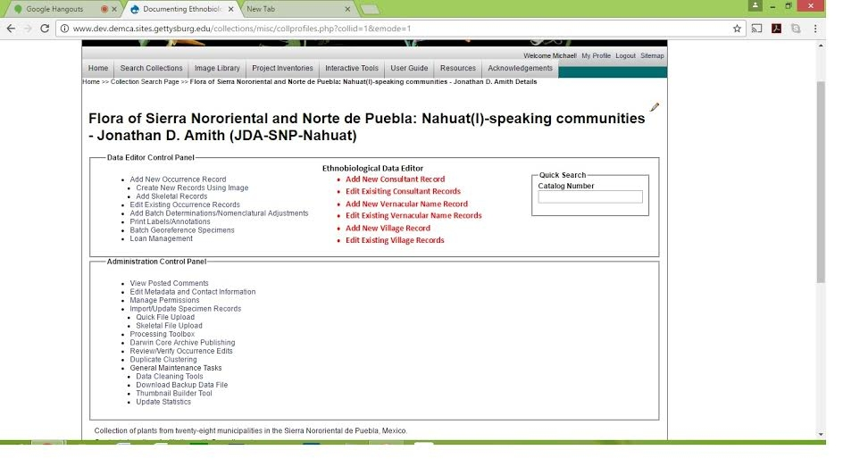

2. Load Glottocode for each language families on the DEMCA server. Note that project managers will enter a terminal language name and DEMCA will then create a taxonomy with higher level groupings.

Perhaps use full Glottocode but definitely write a draft letter as soon as possible and send to Jonathan for review/edit. Note, whether we are successful or not we need to contact Glottocode within this week. We do not want them to find out about this project from third parties and we have been telling people about it.

3. Reload dataset into DEMCA portal

* + Eliminate verbatimCoordinates, verbatimElevation
  + If specificEpithet is ND
    - Eliminate ND
    - Put sp. In identificationQualifier field
    - Verify character encoding is maintained from source file

4. If possible, for Monday have available for review, installation of

Personnel table

Community table

Language table

5. Search collections

Go over this with Jonathan

a. In display in addition to state, country and coordinates

Mexico, Puebla, 19.6523 -97.77738 1170 m

include in the list the municipality

Mexico, Puebla, Cuetzalan del Progreso, …..

b. For Orchids, hide coordinates but make sure municipality and altitude (if possible) is displayed

NOTE: We need to create a tag for community as part of the occurrence record. I will speak to John Wieczorek about how this might be added to Darwin Core

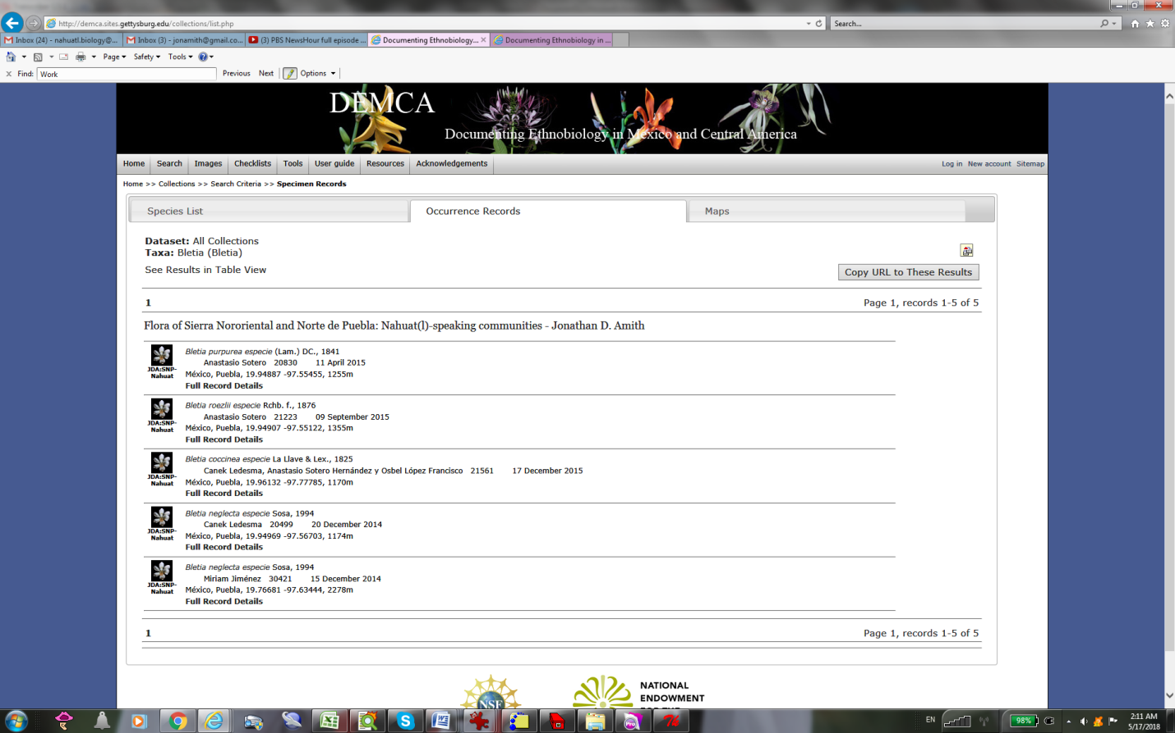

5. During Monday meeting go over above and discuss whether it is possible to upload some 50 photos for a demonstration of photo capabilities of DEMCA/Symbiota